PRESS RELEASE 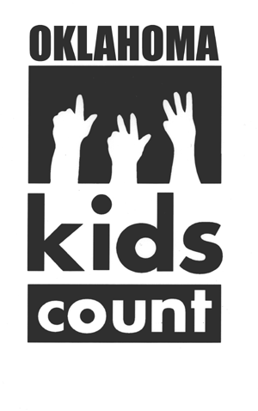 October 8, 2003

EMBARGOED UNTIL OCTOBER 15TH Contact: Anne Roberts, Executive Director

12:00 NOON Work: 405/236-5437 Home: 405/328-6368

OICA Releases the 2003 Oklahoma KIDS COUNT Factbook

(Oklahoma City) The Oklahoma Institute for Child Advocacy (OICA) will release the tenth annual Oklahoma KIDS COUNT Factbook on Wednesday, October 15 at their Fall Legislative Forum. Each year OICA publishes the Factbook to provide the most current data about Oklahoma’s children and to track benchmarks of child well-being in the state. In addition to providing data at a state-level, the KIDS COUNT Factbook takes an in-depth look at data for each of Oklahoma’s 77 counties.

This year’s edition of the Oklahoma KIDS COUNT Factbook is a one-of-a-kind resource for anyone in the state who wants to understand the current situation of Oklahoma’s children. The 2003 Factbook uses the latest census data to provide the most comprehensive state and county demographic information available about Oklahoma’s children, including population, gender, income and race.

Explains Anne Roberts, OICA’s Executive Director, “We are very excited about this book. We have analyzed all of the available 2000 Census data, pulled out the important facts about children and youth in Oklahoma, and put together a resource that will be invaluable for anyone who works with children. This tool can be used for years to come as a guide and resource for advocacy and policymaking.”

The 2003 Oklahoma KIDS COUNT Factbook presents information about children in the contexts in which they live, as individuals, in their families, and in their neighborhoods. This information is presented for the state as a whole and for each of Oklahoma’s counties.

The section on children as individuals breaks down child population by age, looks at race, different types of poverty, opportunities for early childhood education, the number of children with disabilities and statistics about idle teens. The 2003 Factbook finds that statewide the state’s total child population grew substantially between 1990 and 2002, to almost 900,000 children. One in four Oklahomans is under the age of eighteen. The largest single non-White race of Oklahoma’s children is American Indian, while the fastest growing segment of Oklahoma’s young population is Hispanic or Latino.

In looking at children in their families, the KIDS COUNT Factbook focuses on median family income, the composition of families, and grandparents raising grandchildren. The 2000 Census showed that family income in Oklahoma is almost $4,000 lower for families with children than it is for those without. Half of Oklahoma’s children will spend some part of their childhood living with a single parent.

The 2003 Factbook also shows that large numbers of Oklahoma children are growing up in neighborhoods where high poverty is the norm, where it is common for families to be headed by only the mother, where teens regularly drop out of school and where men do not work. Each of these neighborhood factors is discussed individually in the Factbook, and then in a unique analysis, these factors are combined to create a “Disadvantaged Neighborhood Index” ranking counties based on the number of children found in such neighborhoods.

The Oklahoma KIDS COUNT Factbook will be released at 12:00 pm during the lunch session at the OICA Fall Legislative Forum in the University Center Ballroom, 3rd floor, at the University of Central Oklahoma in Edmond. Sandy Ingraham, Factbook data analyst and writer, will introduce the book to an audience of nearly 300 child advocates present for the Forum. Following the Forum she will present a special post-conference workshop on how to get the most from the 2003 Oklahoma KIDS COUNT Factbook.

The Factbook is available through the Oklahoma Institute for Child Advocacy. Books can be ordered by calling 405/236-5437 or writing to 420 NW 13th St., Oklahoma City, OK 73103. The cost of a Factbook is $8 plus $5 for shipping and handling.

--30--

The 2003 Oklahoma KIDS COUNT Factbook will be available on-line for viewing by the press on Monday, October 13. The Factbook can be viewed at that time at http://www.odl.state.ok.us/kids/factbook.

